**Environment is not required if we are using**

Nahi, abhi jo aapka code diya hai usme aap Directory.GetCurrentDirectory() use kar rahe ho, jo project ka root directory de deta hai.

**🔍 Lekin IWebHostEnvironment kab use hota hai?**

Agar aap aise likhna chahte ho



Ya agar aapko wwwroot ya project ke content root ka path chahiye (deployment ke waqt useful), tab IWebHostEnvironment use hota hai.

**🔧 Ye 4 kaam mainly karta hai:**

| **Property** | **Kya kaam karta hai** |
| --- | --- |
| ContentRootPath | App ka **root folder** jaha appsettings.json, .csproj file hoti hai |
| WebRootPath | wwwroot folder ka path deta hai (static files) |
| EnvironmentName | App kis mode me run ho raha hai: Development, Staging, Production |
| ApplicationName | App ka naam (assembly name) |

**✅ Summary:**

| **Condition** | **Use IWebHostEnvironment?** |
| --- | --- |
| Aap sirf Directory.GetCurrentDirectory() use kar rahe ho | ❌ Nahi zarurat |
| Aapko wwwroot, content root, ya hosting path chahiye | ✅ Zarurat hai |

**Example**

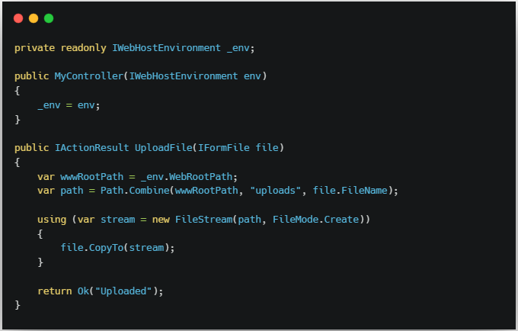

**🧠 Real-world Use Case:**

* Aap image ko wwwroot/uploads/ me save karna chahte ho taaki browser se access ho sake.
* Production me logging kam karna ho, development me zyada.

**Difference between** IwebHostEnvironment **and** GetCurrentDirectory **method**

| **Use Case** | **🔹Kya Use Karein** |
| --- | --- |

|  |  |
| --- | --- |
| ✅ Aapko file wwwroot ya uske sub-folder (like wwwroot/images) me save karni hai | **IWebHostEnvironment.WebRootPath** |

|  |  |
| --- | --- |
| ✅ Aapko project ke kisi custom folder (jaise LocalUploads) me save karna hai jo wwwroot ke bahar hai | **Directory.GetCurrentDirectory()** |

✅ Example 1: wwwroot me upload (Public Access)



**🟢 Advantage**: User browser me https://yoursite.com/images/file.jpg se file access kar sakta hai.

✅ Example 2: Secure folder (Not publicly accessible)

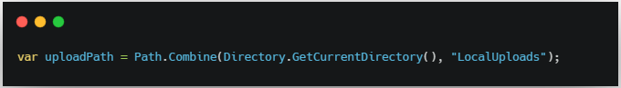

**🔒 Advantage**: File server pe rahegi, browser access nahi kar sakta. Secure data ke liye better.

**🔁 Conclusion:**

✅ Public upload = use IWebHostEnvironment.WebRootPath  
🔒 Private/local upload = use Directory.GetCurrentDirectory()

**Conclusion**

### Simple Summary:

| **📁 Path** | **🔓 Public Access** | **📌 Use** |
| --- | --- | --- |
| IWebHostEnvironment.WebRootPath | ✔️ Haan, browser se access ho sakta hai | Jab image ya file public dikhani ho (wwwroot/images/...) |
| Directory.GetCurrentDirectory() | ❌ Nahi, browser se direct access nahi | Jab image sirf backend use ke liye ho (secure uploads etc.) |

🔓 **Public Image (e.g., Profile Pic URL)**



🔒 **Private File (e.g., Admin-only reports)**

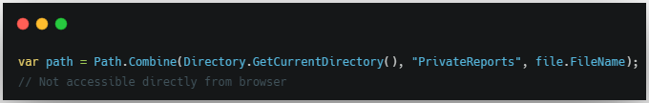

**IWebHostEnvironment, Directory.GetCurrentDirectory(), when and which one should we use**

1. IWebHostEnvironment – **Web hosting environment ke liye**

### Kaha use hota hai?

* Jab aapko **wwwroot (public folder)** ka path chahiye
* Jab aapko check karna ho: app **Development** me hai ya **Production** me
* Jab static files serve karni ho

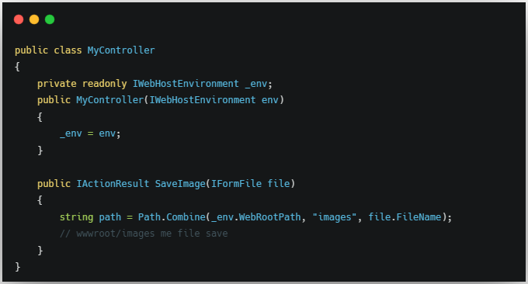

**🟢 Use When:** Aapko file browser se access karni ho (<https://mysite.com/images/file.jpg>)

1. Directory.GetCurrentDirectory() – **Project folder access ke liye**

### Kaha use hota hai?

* Jab aap **project root** (jaha .csproj, appsettings.json hota hai) me koi folder create karna chahte ho
* Jab aapko wwwroot ke bahar secure folder chahiye (e.g., LocalUploads, PrivateFiles)
* Console app ya test project me bhi use hota hai

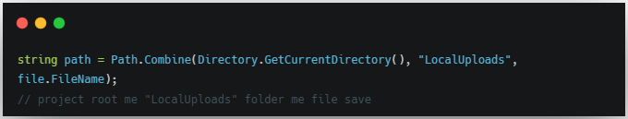

**Note-** Agar aap **IWebHostEnvironment ko use karke file save karte ho lekin wwwroot ke bahar** (jaise LocalUploads folder me), to **bilkul kaam karega**, lekin **file browser se access nahi ho payegi** — kyunki sirf wwwroot hi public hota hai.

✅ Example: LocalUploads folder me file save with IwebHostEnvironment

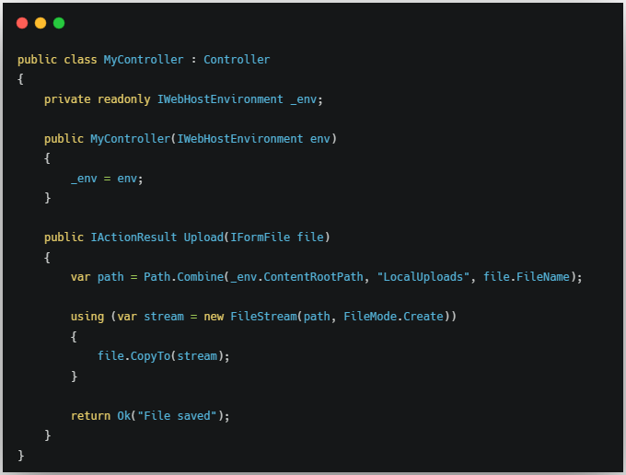

### 📌 Conclusion:

| **Folder** | **Kaise Save Kiya** | **Public Access?** |
| --- | --- | --- |
| wwwroot/uploads | _env.WebRootPath | ✅ Haan |
| LocalUploads | _env.ContentRootPath ya Directory.GetCurrentDirectory() | ❌ Nahi |